|  |  |  |
| --- | --- | --- |
| **Location** | Research School of Chemistry  Building XXX (YYY Wing), Level Z  Room Number #.###  Room Name e.g. “X-Ray Suite” | |
|  | **A T T E N T I O N**  **Authorised Access Only.**  **This Room Contains The Following Hazards:** | |
|  | **Hazard I**  (Sign is an example only – exchange with appropriate hazard symbol).  Describe entry/work requirements | |
| **Macintosh HD:Users:welling:A_TORSTEN_2015-09-09:TS - Signs_and_Notes_and_Notices:Door-signs_and_Facility-signs:Door-Signs_X-ray_Laser_etc:Laser-sign_no_background.png** | **Hazard II**  (Sign is an example only – exchange with appropriate hazard symbol).  Describe entry/work requirements | |
| **Responsible Supervisor(s)** | Professor X | 6125 YY YY  04YY YYY YYY |
| **Technical Support** | Support A (e.g. TO) | 6125 XX XX |
| Support B (e.g. Workshop) | 6125 XX XX |
| **Emergency** | ANU Security | 6125 22 49 |
| Emergency Services (Fire, Hazmat) | 000 (0-000 from RSC phones) |
| RSC WHS Manager | 0404 823 154 |
| RSC on-call response | 0436 637 121 |
| RSC on-call response | 0436 637 121 |
| RSC Facilities Manager | 0436 641 406 |

**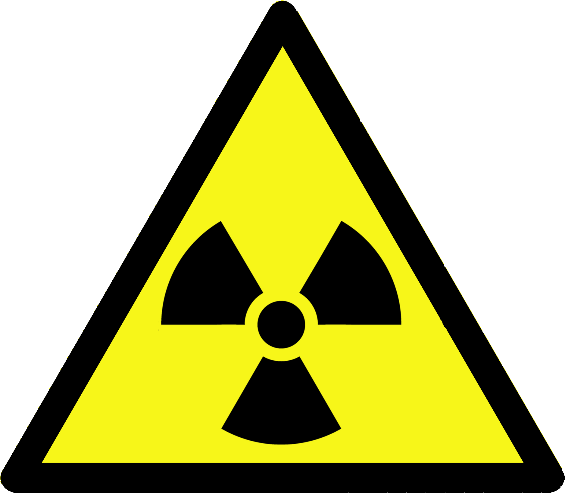**

The following warning symbols can be pasted into the above template if required, then only the first page (see above) gets printed and displayed.

|  |  |  |
| --- | --- | --- |
| **Macintosh HD:Users:welling:A_TORSTEN_2015-03-16:TS - Signs_and_Notes:Door-signs_and_Facility-signs:Door-Signs_X-ray_Laser_etc:Radioactive-sign_triangle.png** | **Macintosh HD:Users:welling:A_TORSTEN_2015-09-09:TS - Signs_and_Notes_and_Notices:Door-signs_and_Facility-signs:Door-Signs_X-ray_Laser_etc:Laser-sign_no_background.png** |  |
| Ionising radiation (e.g. X-Ray) | Laser radiation | Attention |
|  |  |  |
| Cryogenic liquid | Hazardous chemicals | UV and Microwave |
|  |  | **Macintosh HD:Users:welling:A_TORSTEN_2016-03-12:TS - Signs_and_Notes_and_Notices:DGC-symbols:DGC-diamond_Toxic_Gas.png** |
| High voltage |  | Toxic gas (DGC 2.3) |
| **Macintosh HD:Users:welling:A_TORSTEN_2016-03-12:TS - Signs_and_Notes_and_Notices:DGC-symbols:DGC-diamonds_roatated:DGC-diamond_5-1_Oxidising_Agent.png** | **Macintosh HD:Users:welling:A_TORSTEN_2016-03-12:TS - Signs_and_Notes_and_Notices:DGC-symbols:DGC-diamonds_roatated:DGC-diamond_8_Corrosive.png** | C:\Users\RSC USER\Desktop\Adam\2016_02_23\mag.png |
| Oxidising agent (DGC 5.1) | Corrosive substance (DGC 8) | Magnetic fields |
|  |  |  |
| Flammable Gas (DGC 2.1) | DGC 2.2 | DGC 3 |
|  |  |  |
| DGC 6.1 | DGC 9 |  |
| C:\Users\u4450603\AppData\Local\Microsoft\Windows\INetCache\Content.Word\DGC 4-1 rotated.png | C:\Users\u4450603\AppData\Local\Microsoft\Windows\INetCache\Content.Word\DGC 4-2 rotated.png | C:\Users\u4450603\AppData\Local\Microsoft\Windows\INetCache\Content.Word\DGC 4-3 rotated.png |
| DGC 4.1 | DGC 4.2 | DGC 4.3 |