Fridge not intrinsically safe

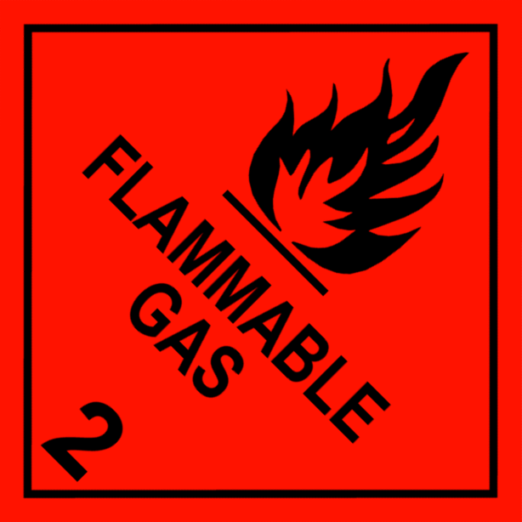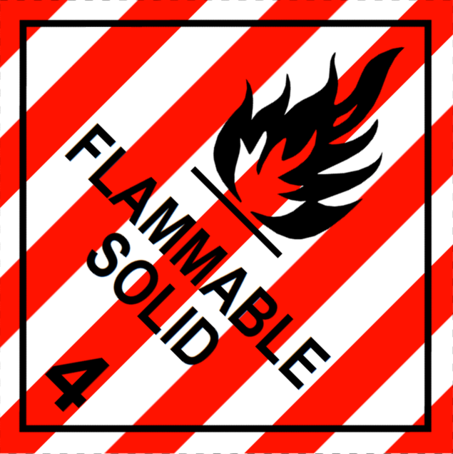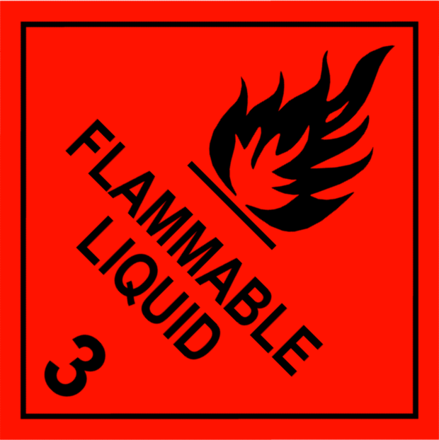Do not store
- Flammable liquids
- Flammable solids
- Flammable gases
- Food/drink

All chemicals stored must be labelled appropriately and double contained (e.g. trays).

Fridge not intrinsically safe

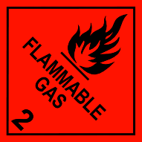
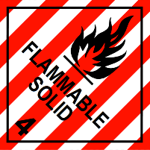
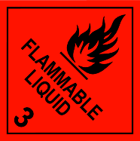
Do not store
- Flammable liquids
- Flammable solids
- Flammable gases
- Food/drink

All chemicals stored must be labelled appropriately and double contained (e.g. trays).

