|  |  |  |  |
| --- | --- | --- | --- |
| **Location** | Research School of Chemistry  Building xxx (North/South Wing)  Level Y, Room Z.ZZZ | | |
|  | **A T T E N T I O N**  **This Laboratory Contains Hazardous Chemicals. Authorised access only** | | |
|  | | | |
| **Responsible Supervisor(s)** | Supervisor A | | 6125 xxxx |
| 04xx xxx xxx |
| Supervisor B | | 6125 yyyy |
| 04yy yyy yyy |
| **Emergency Response** | ANU Security | | 6125 2249 |
| Emergency Services (Fire, Hazmat) | | 000 (0-000 from RSC phones) |
| RSC on-call response | | 0436 637 121 |
| RSC TS&WHS Manager  RSC WHS Manager | | 0404 823 154 |
| RSC Building Operations Manager | | 0436 641 406 |
| Allocations and contact details correct as of (dd/mm/yyyy): | | To be reviewed at least every 12 months | |
| Allocations and contact details correct as of (dd/mm/yyyy): | | To be reviewed at least every 12 months | |

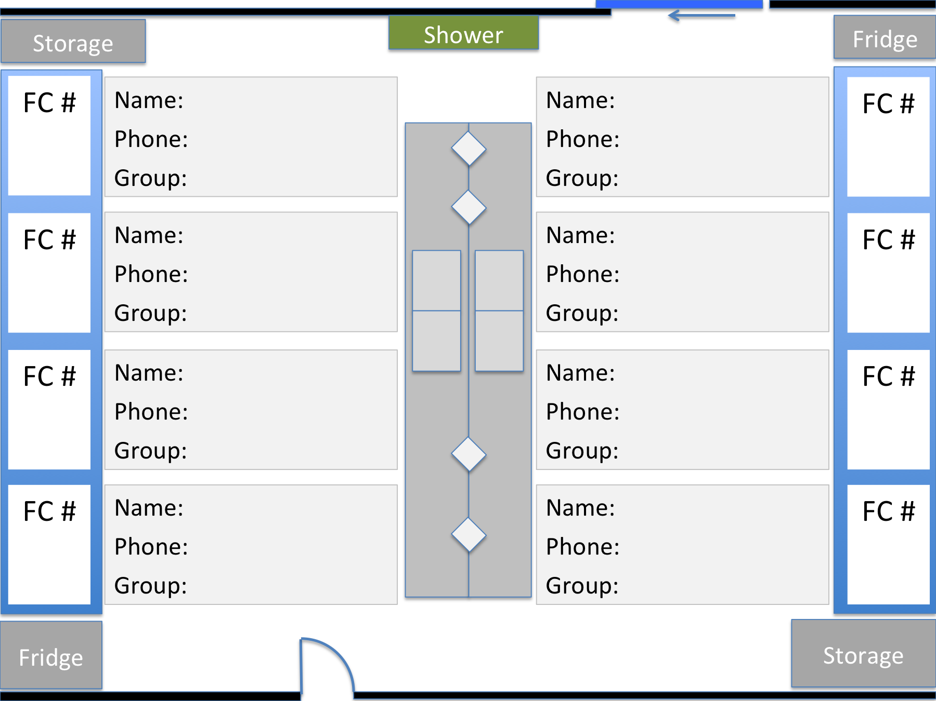

A

A

A

B

B

B

C

C

C

D

D

D

E

E

E

F

F

F

G

G

G

H

H

H

X-XX

X-XX

X-XX

X-XX

X-XX

X-XX

X-XX

X-XX